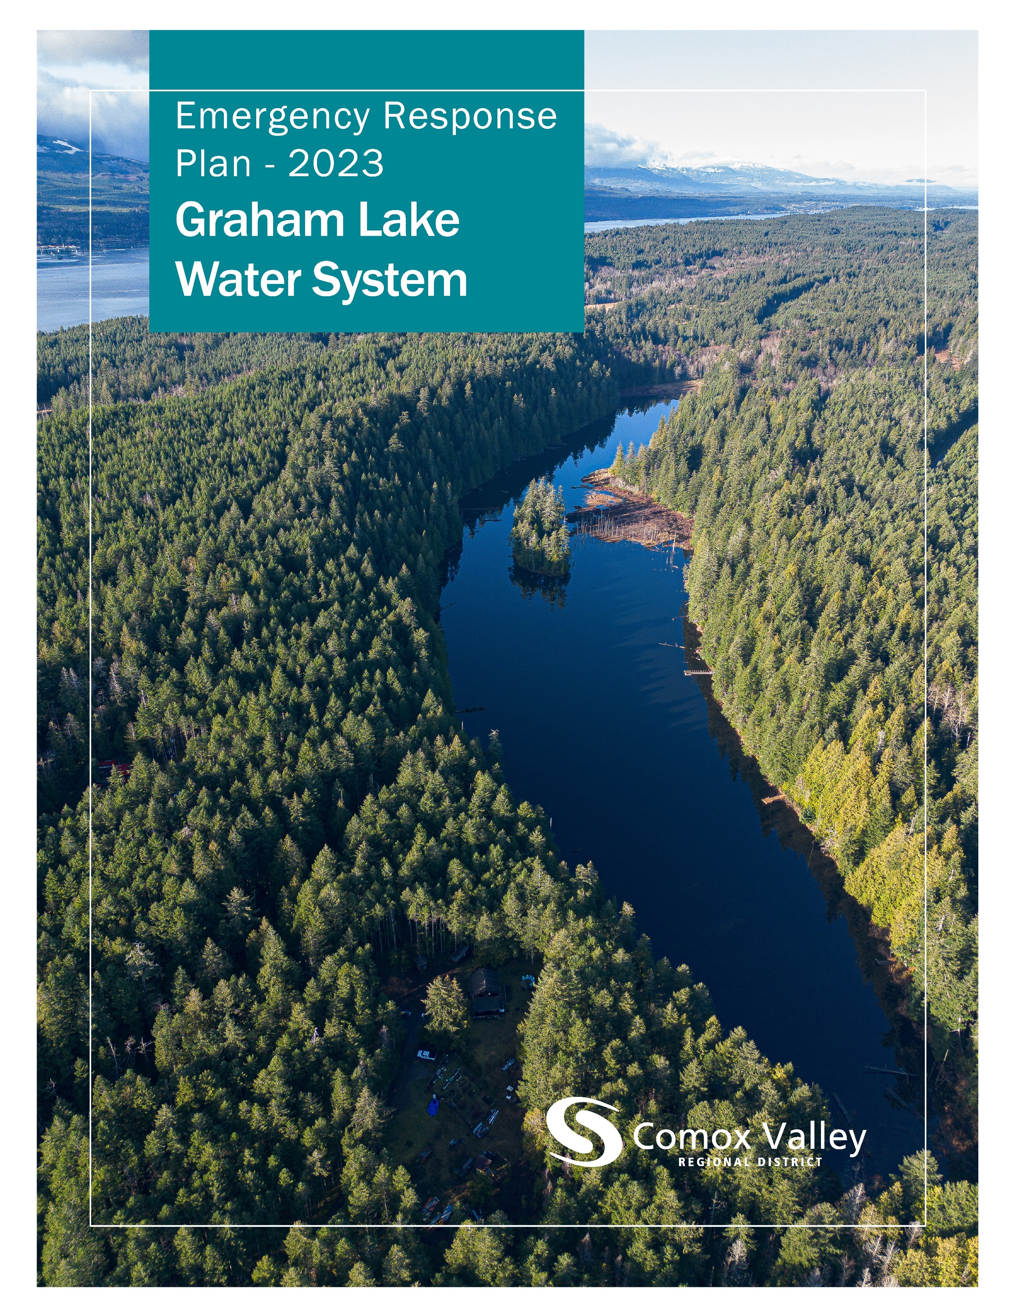

**Table of Contents**

Introduction 3

Type of Emergency 3

Loss of Power 3

Earthquake 3

Drought 4

Turbidity 4

Contamination 5

Communications 6

Emergency Contacts 8

The CVRD respectfully acknowledges that the land on which it operates is the unceded territory of the K'ómoks First Nation, the traditional keepers of this land.

# **Introduction**

An ‘emergency’, within the scope of this document is defined as anything that could cause illness or injury to a resident within the Graham Lake Water System. The purpose of this plan is to acknowledge potential crises, anticipate potential hazards, and prepare for events in advance.

Generally, the communications component of a response to an emergency will be administered as needed, and whichever means best suits the level of urgency will be used.

# **Type of Emergency**

## **Loss of Power**

The loss of power will activate the standby generator to provide electricity to the Graham Lake treatment facility. The on-call operator will receive an alarm notification advising that the generator is on and will take the following actions:

* Respond to the alarm and assess the situation.
* Contact BC Hydro (1-888-769-3766), notify them, and request an estimate of the duration of the power outage.
* Ensure that the generator is running properly and check fuel levels.
* Ensure that the treatment equipment is operating properly.
* Refuel the generator if the outage is anticipated to last for an extended period. Total capacity of the propane tank is 1813L with an expected run time of 639 hours.
* Once power is restored arrange to have the generator refueled.

Uninterruptible power supplies will maintain data logging and limited control in the event of a power failure.

## **Earthquake**

Earthquake response is dependant on the impacted infrastructure and the severity of the damage. In a scenario involving broken water distribution mains the objective is to preserve as much water as possible by isolating damaged sections or the water system.

Response to the loss of a water supply main is dependant on the cause and extent of damage to the source or supply system, but the course of action will generally resemble the following:

* + Notify the Manager of Water Services, the Supervisor of Water Treatment, and the Supervisor of Distribution/Transmission.
  + Notify the Vancouver Island Health Authority.
  + Assess affected infrastructure, classify the damage, prioritize the work, and coordinate a response plan. If there is washout from a dam breach or transmission main failure, notify the Ministry of Environment.
  + Notify any agencies that would be affected by disruption of service. A boil water or restrictive water use notice may need to be issued.
  + Isolate the affected area, make repairs, and flush.
  + Collect and test samples before reinstitution.
  + Remove water advisories.
  + Replace materials used.

## **Drought**

Drought response is dependent on the severity of the drought. Historically, lake level has not been significantly affected by drought and there are no requirements to maintain creek flow below the dam. Lake level and spillway conditions are monitored weekly by staff, but the Graham Lake Water System does not currently have a conservation bylaw in place to respond to drought conditions. However, residents of the service area are cooperative with conservation efforts, familiar with other notices affecting their water, and it is expected that utilizing existing communication methods with residents to reduce consumption in a drought scenario would be effective.

## **Turbidity**

Turbidity is continuously monitored by instruments at the treatment facility. If turbidity exceeds 1 nephelometric turbidity unit, the on-call operator will receive an alarm notification and will take the following actions:

* + Respond to the alarm, assess the situation, and check equipment for calibration/proper operation.
  + Notify the Manager of Water Services, the Supervisor of Water Treatment, and the Supervisor of Distribution/Transmission.
  + Notify the Vancouver Island Health Authority.
  + If a Boil Water Notice is needed, develop a communications plan and notify customers.
  + Confirm that adequate chlorine levels exist throughout the distribution system.
  + Test turbidity levels throughout the distribution system. If levels are above 1 NTU, flush the distribution mains until NTU is below 1.
  + When turbidity levels in the distribution system have been reduced to less than 1 NTU, rescind the Boil Water Notice.

## **Contamination**

If there is contamination or suspected contamination of the source water, the following steps will be carried out:

* + Notify the Manager of Water Services, the Supervisor of Water Treatment, and the Supervisor of Distribution/Transmission.
  + Close the inlet valve.
  + Assess the source and the extent of the contamination within the water system. If contamination has spread to the distribution system, see below.

If the contamination is determined to be from fuel in the source water, develop and employ a hydrocarbon sampling strategy. Contact the Emergency Management BC Emergency Coordination Centreand advise them of the nature of the emergency. If possible, contain the contamination with absorbent floating booms from the spill response container located at Comox Lake. Once contamination is contained, sample until source water is clean.

* + Flush and sample.
  + Once repeat samples are clean, the isolated area may be brought back online.

If there is contamination or suspected contamination of the water distribution system, the following steps will be carried out:

* + Notify the Manager of Water Services, the Supervisor of Water Treatment, and the Supervisor of Distribution/Transmission.
  + If a Boil Water Notice is needed, develop a communications plan and notify customers. Additional advisories may be required after determining the cause of contamination.
  + Notify the Vancouver Island Health Authority.
  + Sample and assess the extent of the contamination.
  + Isolate affected area.
  + Flush and sample.
  + Once repeat samples are clean, the isolated area may be brought back online.
  + Issue communications to remove the Boil Water Notice.

# **Communications**

The Manager of Water Services will alert the Communications Department about any water emergencies. A decision on the level of response will be made in conjunction with the department and the GM of Engineering and/or the Senior Manager of Water and Wastewater.

The Crisis Communications Plan applies to incidents that occur within the CVRD and for which the CVRD has direct jurisdictional authority. The CVRD will assume lead responsibility for all emergency communications in those jurisdictional areas, and for those components of infrastructure and services for which the CVRD has direct accountability, including the following actions:

* + Messaging citizens through Connect Rocket
  + Posting an emergency banner on the CVRD website
  + Advising the Water Committee and CVRD Board Chair
  + Advising CVRD staff
  + Preparing a press release and distributing to local media outlets
  + Posting updates to social media
  + Posting updates to the website
  + Drafting FAQs and key messages
  + Responding to social media inquiries

# **Emergency Contacts**

|  |  |
| --- | --- |
| **External Agency** | **Contact** |
| Denman Island Fire Department | (250) 335-0345 |
| R.C.M.P. | (250) 338-1321 |
| Brenntag Canada Emergency | (604) 685-5036 |
| North Island Hospital Comox Valley | (250) 331-5900 |
| VIHA Environmental Health Officer – Ella Derby | (250) 331-8607 |
| VIHA Environmental Health Officer – Nancy Clements | (250) 923-1343 |
| VIHA Public Health Engineer – Darrell Belanger | (250) 331-8518 |
| VIHA Medical Health Officer – Dr. Charmaine Enns | (250) 331-8591 |
| VIHA After-Hour Emergency | (800) 204-6166 |
| Emergency Management BC 24/7 Coordination Centre | (800) 663-3456 |
| Ministry of Environment | (800) 663-3456 |
| Center for Disease Control | (604) 661-7033 |
| Bureau Veritas – Analytical Services | (250) 338-7786 |
| BC Hydro Vancouver Island | (250) 701-4611 |
| BC Hydro Report and Outage | (888) 769-3766 |
| WorkSafe BC – Worksite Emergency | (888) 621-7233 |
| Prices Alarms – Emergency Response Centre | (888) 817-8415 |
| City of Courtenay City Hall | (250) 334-4441 |
| City of Courtenay Public Works Yard | (250) 338-1525 |
| Town of Comox City Hall | (250) 339-2202 |
| Town of Comox Public Works Yard | (250) 339-2485 |
| K'ómoks First Nation | (250) 339-4545 |
| **Comox Valley Regional District** | **Contact** |
| Manager of Water Services – Mike Herschmiller | (250) 218-9699 |
| Manager of Emergency Programs – Howie Siemens | (250) 334-2002 |
| Emergency Planning Coordinator – Cari McIntyre | (250) 334-6096 |
| Senior Operator – Water Transmission and Distribution – Steve Prunkle | (250) 218-3207 |
| Senior Operator – Water Treatment – Jarrett Morka | (250) 207-0307 |
| Leadhand – Water Distribution and Transmission – Gavin Waterfield | (250) 207-0294 |
| Leadhand – Water Treatment – Tyler Robertson | (236) 255-3437 |
| Water Utilities Technician – Kaleb Leskiw | (250) 218-4171 |
| Waterworks Operator – Transmission and Distribution – Danny McGill | (250) 207-4300 |
| Waterworks Operator – Transmission and Distribution – Steve Russell | (250) 207-0307 |
| Waterworks Operator – Transmission and Distribution – Eric Cox | (250) 207-0297 |
| Waterworks Operator – Transmission and Distribution – Kerry Bird | (250) 897-6677 |
| Waterworks Operator – Transmission and Distribution – Paul Turney | (250) 207-6700 |
| Waterworks Operator – Transmission and Distribution – Patrick Roesch | (250) 650-5117 |
| Waterworks Operator – Transmission and Distribution – Kyle Jorgensen | (778) 585-4497 |
| Waterworks Operator – Transmission and Distribution – Keith McKay | (250) 207-4600 |
| Waterworks Operator – Transmission and Distribution – Jamie Pratt | (250) 650-1091 |
| Waterworks Operator – Treatment – Kate Norkum | (250) 207-4300 |
| Waterworks Operator – Treatment – Sonya Jenssen | (250) 207-4900 |