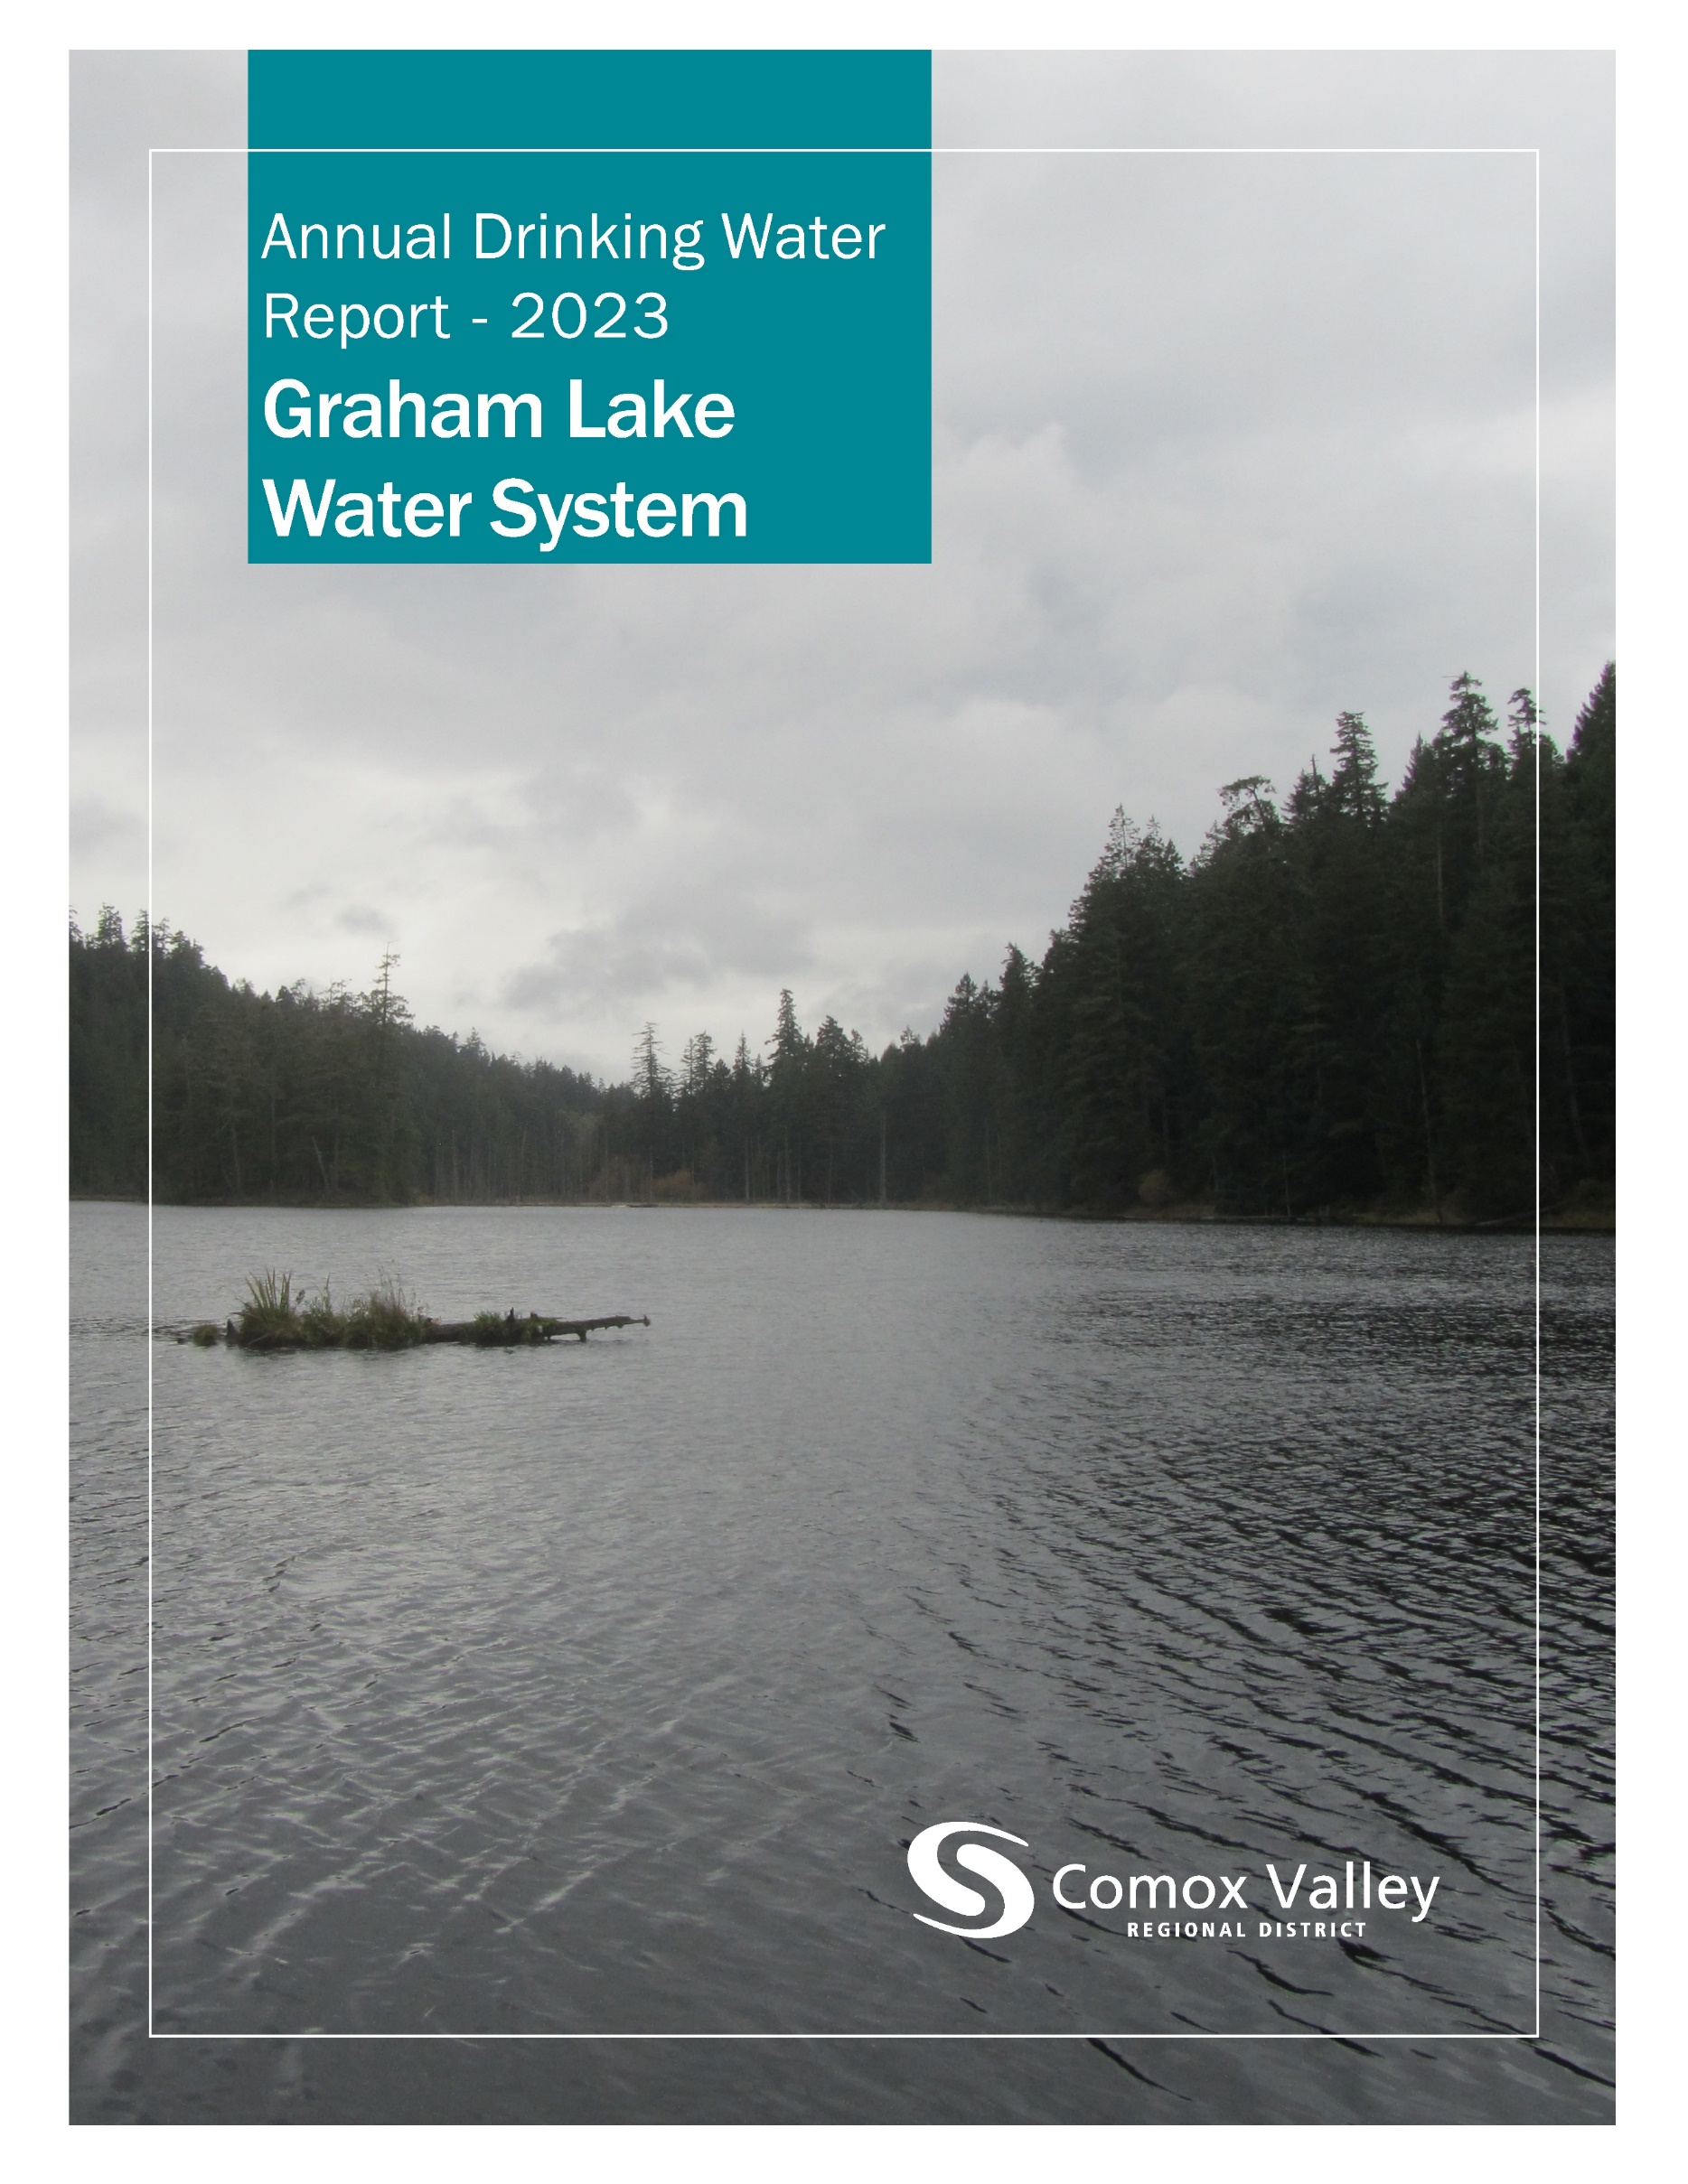

**Table of Contents**

**Introduction** 2

**Source Water** 3

**Water Treatment** 3

**Water Distribution** 4

**Water Quality** 4

**Water Quality Summary** 4

# **Introduction**

The Comox Valley Regional District strives to provide high-quality drinking water through responsible operation and management of the water system. The CVRD is regulated by Island Health for its activities as a potable water supplier and is required under the *Drinking Water Protection Act* to report annually on the Graham Lake Water System. This report includes information on water quality, consumption, maintenance, and capital projects.

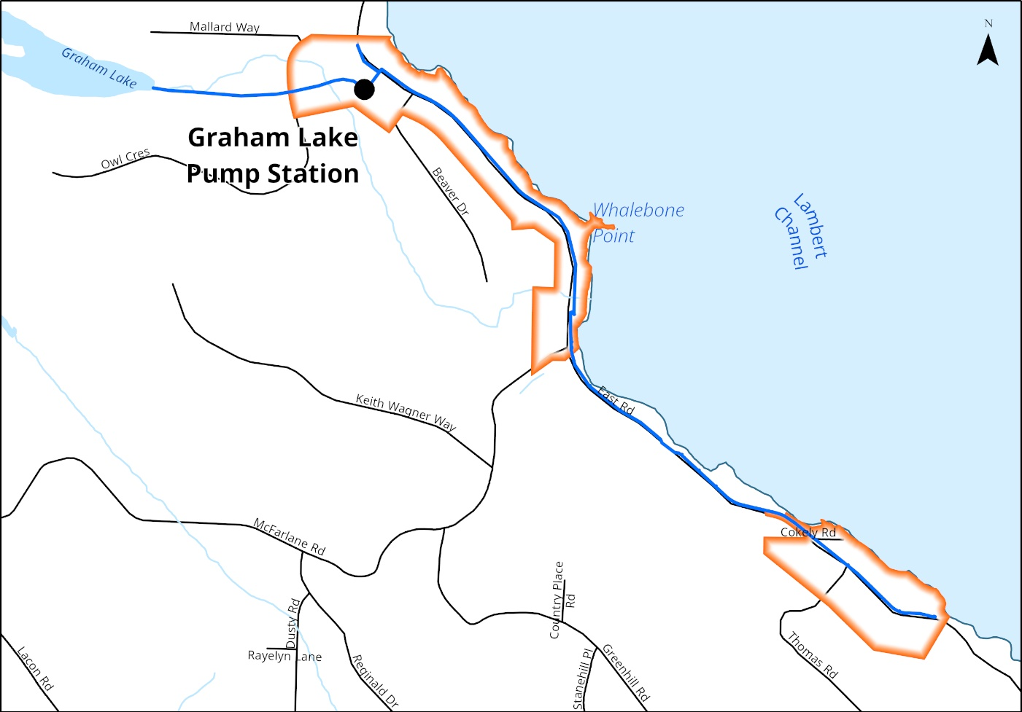The CVRD provides water to roughly 174 residents in the Graham Lake Service Area.

# **Source Water**

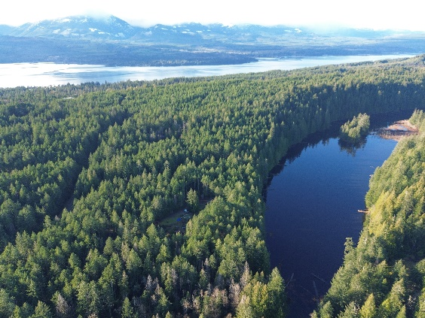Water for the Graham Lake Service Area is sourced from Graham Lake, a 1.3km long body of water surrounded by forest and adjacent to the Lindsay Dickson Nature Reserve.

The reservoir holds approximately 200 megaliters, and ranges in capacity depending on the season.

*Graham Lake.*

# **Water Treatment**

All water supply systems using surface water are governed by Island Health and are required to adhere to provincial “4-3-2-1-0” treatment objectives to ensure effective elimination of disease-causing viruses, bacteria, and parasites.

The “4-3-2-1-0” objectives are as follows:

* 4-log (99.99 per cent) removal/inactivation of viruses
* 3-log (99.9 per cent) removal/inactivation of Giardia and Cryptosporidium
* 2 types of treatment processes
* 1 maximum Nephelometric Turbidity Units in treated water
* 0 detectable E. Coli, fecal coliforms and total coliforms in treated water

The journey from source to tap begins above the bed of Graham Lake where water enters the screened intake and flows 750m to the water treatment facility. When it arrives, it flows through two parallel sand filters which strain out smaller particulate and ultra violate reactors which deactivate bacteria. Then the water is injected with sodium hypochlorite before entering a stainless-steel tank. After adequate contact time, it enters the distribution system.

# **Water Distribution**

Water leaves the treatment facility and travels southward along East Road servicing 67 homes and 5 fire hydrants.

# **Water Quality**

The Ministry of Health, through its regional body Island Health, regulates municipal drinking water quality through the *Drinking Water Protection Act* and the *Drinking Water Protection Regulation*. Both documents set out certain requirements for drinking water purveyors to ensure the provision of safe drinking water to their customers.

The *Guidelines for Canadian Drinking Water Quality* are developed by the Federal-Provincial-Territorial Committee on Drinking Water, and they provide a limit on microbial, chemical, physical, radiological substances called a “maximum acceptable concentration”. The guidelines also assign aesthetic objectives to substances that do not cause risk to human health, but influence consumer acceptance of the water based on factors such as taste, odour and colour.

The CVRD uses in-line analyzers to monitor raw water from Graham Lake, treated water leaving the facility, and at points throughout the treatment process. Weekly water quality samples from various strategic points within the distribution system are also collected to ensure that water is meeting regulatory objectives. Additionally, beyond the scope of this document, water from select locations is tested periodically throughout the year for many different analytes to confirm the effectiveness of treatment processes, the quality of our source water, and the integrity of the distribution system.

# **Water Quality Summary**

|  |  |  |  |  |  |  |  |  |  |  |  |
| --- | --- | --- | --- | --- | --- | --- | --- | --- | --- | --- | --- |
|  | **4356 East Road** | | | | | | | | | |  |
| **Date** | **Total Coliform** | **E. Coli** | **Date** | **Total Coliform** | **E. Coli** | **Date** | **Total Coliform** | **E. Coli** | **Date** | **Total Coliform** | **E. Coli** |
| **03-Jan** | LT1 | LT1 | **04-Apr** | LT1 | LT1 | **04-Jul** | LT1 | LT1 | **25-Sep** | LT1 | LT1 |
| **11-Jan** | LT1 | LT1 | **11-Apr** | LT1 | LT1 | **10-Jul** | LT1 | LT1 | **03-Oct** | LT1 | LT1 |
| **17-Jan** | LT1 | LT1 | **18-Apr** | LT1 | LT1 | **17-Jul** | LT1 | LT1 | **10-Oct** | LT1 | LT1 |
| **24-Jan** | LT1 | LT1 | **25-Apr** | LT1 | LT1 | **24-Jul** | LT1 | LT1 | **16-Oct** | LT1 | LT1 |
| **01-Feb** | LT1 | LT1 | **02-May** | LT1 | LT1 | **08-Aug** | LT1 | LT1 | **23-Oct** | LT1 | LT1 |
| **07-Feb** | LT1 | LT1 | **09-May** | LT1 | LT1 | **14-Aug** | LT1 | LT1 | **06-Nov** | LT1 | LT1 |
| **15-Feb** | LT1 | LT1 | **16-May** | LT1 | LT1 | **21-Aug** | LT1 | LT1 | **14-Nov** | LT1 | LT1 |
| **21-Feb** | LT1 | LT1 | **23-May** | LT1 | LT1 | **28-Aug** | LT1 | LT1 | **20-Nov** | LT1 | LT1 |
| **01-Mar** | LT1 | LT1 | **30-May** | LT1 | LT1 | **30-Aug** | LT1 | LT1 | **27-Nov** | LT1 | LT1 |
| **08-Mar** | LT1 | LT1 | **06-Jun** | LT1 | LT1 | **05-Sep** | LT1 | LT1 | **04-Dec** | LT1 | LT1 |
| **15-Mar** | LT1 | LT1 | **13-Jun** | LT1 | LT1 | **11-Sep** | LT1 | LT1 | **11-Dec** | LT1 | LT1 |
| **21-Mar** | LT1 | LT1 | **20-Jun** | LT1 | LT1 | **18-Sep** | LT1 | LT1 | **18-Dec** | LT1 | LT1 |
| **28-Mar** | LT1 | LT1 | **28-Jun** | LT1 | LT1 | **25-Sep** | LT1 | LT1 |  |  |  |